The AutoIt script for flatbed scanner control: paste these lines into the AutoIt script editor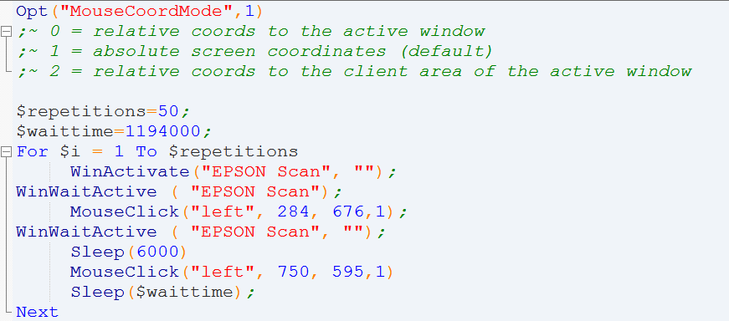
Note: The numbers in the step “MouseClick” should be adjusted to the position of the respective bottoms in the open window in one’s own computer using the AutoIt Window Info tool. Since then, avoid moving the position of the window of the scanning program.

The FIJI script for the segment measurement:
// 03-Nov-2016 - Hypocotyl script V1.0 – G. Krens - I.S.T. Austria
// This macro will analyze the longest axis of an object (FERET) which is segmented out of a user selected ROI,
// The analysis is performed over all frames, and looped over all defined ROIs

//Open image, set path and image-id
run("Image Sequence...");
dir = getDirectory("image");
id = getTitle();

// Set measurement settings to measure longest axis particle
run("Set Measurements...", "feret's redirect=None decimal=3");

// Go to last frame of opened image sequence
N = nSlices;
setSlice(N);

//ask user to set all ROIs to be analyzed, using 'rectangle' selection tool
setTool("rectangle");
roiManager("Add ALL YOUR ROIs");
waitForUser("select your ROIs in the last frame")

// set loop to run analysis over all ROIs
for (i=0 ; i<roiManager("count"); i++) {
selectImage(id);
roiManager("select", i);

// 1) Duplicate ROI for analysis
run("Duplicate...", "duplicate");
ROIname = getTitle;

// 2) Improve image of ROI for particle analysis
run("Remove Outliers...", "radius=8 threshold=50 which=Bright stack");
run("Gaussian Blur...", "sigma=3 stack");

// 3) Set threshold automatically on ROI
setAutoThreshold("Default dark");
run("Make Binary", "method=Default background=Dark calculate black");

// 4) Set mask
run("Convert to Mask", "method=Default background=Dark calculate black");

// 5) Analyze
run("Analyze Particles...", "size=1000-Infinity circularity=0.00-0.99 display exclude summarize stack");

//6) save measured results per ROI
name = getTitle;
index = lastIndexOf(name, ".");
if (index!=-1) name = substring(name, 0, index);
name = name + ".txt";
saveAs("Measurements", dir+name);
print(dir+name);
run("Close");
}

// optional: Save all results in a single table (concatenated)
if (isOpen("Results")) {
selectWindow("Results");
saveAs("Results", dir+id+ "summary.txt");
run("Close");
}

// close all open image windows
run("Close All");

The AreaKymo script, to be pasted into MATLAB as a script

____________________________________________________________

%areaKymo
%inputs are 16 bit 2-channel, multitime tif images with green channel first, red
%channel second. Red channel is the reference channel - works for GFP/RFP
%pH sensors, but should also work for R2D2-type sensors.
%I use SUM projection of z-stacks - these are 32 bit, convert carefully to
%16bit, do not loose information during the conversion.

%orient the picture in the way that the interesting features are aligned
%vertically as much as possible

%find out the threshold when your red channels is well thresholded - you see just the feature you care about, in my case cell walls.
% input this as threshold.

clear all; close all;

%parameters
%________________________________________________________

threshold= 14000; %set manually based on the red channel. set threshold=-1 to automatically determine the threshold
twidth=15; %define the length of single timepoint in pixels = twidth
ratioRange=[0 2]; % y range in box plot
ratioLimit=2; % limit the maximum Ratio to this value, set ratioLimit=Inf if you don not want to limit the Ratio
% limiting the ratio is useful if the images are very noisy
%________________________________________________________

[sName,sNewPath]= uigetfile('*.tif','Select the image');
cd(sNewPath);
info = imfinfo(sName);
dimx=info(1).Width;
dimy=info(1).Height;
xres=info(1).XResolution;
yres=info(1).YResolution;
nt = numel(info)/2;
g=zeros(dimy,dimx, nt);
r=zeros(dimy,dimx, nt);
disp('reading image file ... stay tuned ');
for k = 1:nt
g(:,:,k)=imread(sName, 2*k-1, 'Info', info);
r(:,:,k)=imread(sName, 2*k, 'Info', info);
end
figure(1);
imshow(imfuse(r(:,:,1),g(:,:,1),'falsecolor','ColorChannels',[1 2 0]));
title(sName);

minE=Inf;
for k = 1:nt
im1=r(:,:,k);
m1=im1(im1>threshold);
if numel(m1)<minE
minE=numel(m1);
end;
end;

basewidth = fix(minE/twidth);

minE=twidth*basewidth;
subimsize=[basewidth minE/basewidth];
r1=zeros([ subimsize(1) subimsize(2)*nt]);
g1=r1;

if threshold<0
autothresh=multithresh(r(:,:,1),3);
threshold=autothresh(end);
end;

for k = 1:nt
im1=r(:,:,k);
im2=g(:,:,k);
m1=im1(im1>threshold);
m2=im2(im1>threshold);
r1(:,(k-1)*subimsize(2)+1:k*subimsize(2))=reshape(m1(1:minE),subimsize);
g1(:,(k-1)*subimsize(2)+1:k*subimsize(2))=reshape(m2(1:minE),subimsize);
end;

figure(2);
%calculate the ratio image, best visualized by the Fire LUT
ratio=r1./g1*10000; %mutliply with 10000 to save as 16bit tif
imwrite(uint16(ratio'),[sName(1:end-4) '_ratioRG.tif']);
imshow([sName(1:end-4) '_ratioRG.tif']);
title('Ratio red/green');
colormap hot;

figure(3); %this one shows the GFP and RFP channels, mind that the LUT of the RED must be changed, otherwise starts at the threshold.
maxint=max([max(max(r1)) max(max(g1))]);
r1=r1./maxint*65535;
g1=g1./maxint*65535;
imshow(imfuse(r1',g1','falsecolor','ColorChannels',[1 2 0]));
title('Overlay Red+Green');
imwrite(uint16(r1'),[sName(1:end-4) '_r.tif']);
imwrite(uint16(g1'),[sName(1:end-4) '_g.tif']);

disp('calculating ratios ... ');
%get the numbers from the total (non shrunk) thresholded images, calculate the ratio
%between Green to Red

TOT = [];
grp = [];
for k = 1:nt
Red1=r(:,:,k);
Gre2=g(:,:,k);
Red=Red1(Red1>threshold);
Gre=Gre2(Red1>threshold);
Rat=Gre./Red;
Rat(Rat>ratioLimit)=ratioLimit;
grp = [grp,k*ones(1,numel(Rat))];
TOT= [TOT;Rat];
end;
fig = figure;
h=boxplot(TOT,grp);
set(h(7,:),'Visible','off') %remove outliers

ylim(ratioRange); %the range can be specified...
title('Ratio Green/red (t)');
xlabel('frame #');
ylabel('Ratio');
print(fig,[sName(1:end-4) '_boxplot'],'-dpng');

disp('done ... ');

